Automating Traffic Microsimulation From UTDF To SUMO

Xiangyong Luo1, Yiran Zhang2, Guanhao Xu1, Wan Li1, Ross Wang1 and Xuesong Simon Zhou3

1 Buildings & Transportation Science Division, Oak Ridge National Laboratory (ORNL), Oak Ridge, TN

2 The Intelligent Urban Transportation System (iUTS) Lab, Department of Civil and Environmental Engineering, University of Washington, United States

3 School of Sustainable Engineering and the Built Environment, Arizona State University, 660 S. College Avenue, Tempe, AZ 85287-3005, USA

ABSTRACT

Modern transportation research relies on seamlessly integrating traffic signal data with robust network representation and simulation tools. We present utdf2gmns, an open-source Python tool that automates the conversion of Synchro’s UTDF Format, including network representation, signalized intersections, turning volumes into the GMNS Standard. The resulting GMNS-compliant network can be used for simulation in SUMO. By automatically extracting intersection control parameters and aligning them with GMNS conventions, utdf2gmns minimizes manual preprocessing and reduces data loss. It also integrates with the sigma-x engine to extract and visualize key traffic control metrics such as phasing diagrams, turning volumes, movement capacities, volume-to-capacity (V/C) ratios, and control delays. This streamlined workflow enables efficient scenario testing, accurate model building, and consistent data management. Validated through case studies, utdf2gmns reliably models complex urban corridors. As a free, open-source solution, it promotes reproducibility and standardization. Documentation is available on [GitHub](https://github.com/xyluo25/utdf2gmns) and [PyPI](https://pypi.org/project/utdf2gmns/), supporting easy integration and community engagement.

# INTRODUCTION

Existing work and shortages

UTDF

GMNS

Challenges in signal conversion

Challenges in network conversion

The current methodology and necessaries

# METHODOLOGY

To automatically convert Synchro network (in UTDF format) to SUMO for extended microsimulation, with high accuracy, there are many aspects need to consider, such as how to accurately convert the original network (Use relative coordinates) to real-world coordinates (longitude and latitude), how to extract signal information from original file and then convert to SUMO, how to convert the turning flow, and how to calculate key performance features. Methods in this chapter solve these problems.

## Network Coordinating

The first and most important for the automation process is to convert the Synchro network to the real-world network so that the network can be opened using GIS software. In this part, we introduce two methods to convert original network to general readable network. The first method will automatically geocoding intersections and the second method will need use manually input one intersection with its coordinate.

### Automatic Geocoding

Benefits from the UTDF file that include names of link on each direction at the intersection (Figure 1), the logic (Figure 2) is to loop through each intersection and extract names of each direction, then using double confirmation method to get the coordinate of the intersection, if the coordinate of the intersection validated, the loop will stop, else move to next intersection and validate the intersection. In the worst case there is no coordinate validated, the program will then pop out the message to ask the user to confirm the location of network representation or navigate to manual geocoding method. After the coordinate of one intersection have been validated, then mapping / coordinating all intersections from the validated coordinate by converting relative coordinates to real-world relative position.

Add figure of one intersection with lane name



Figure 1 Two methods of coordinating intersections

### Manual Geocoding with One Known Coordinate

Manual geocoding will also take the minimum effort as only one coordinate is needed. In this part, only one thing needs to be done is to confirm the intersection id with its coordinate (e.g.: {“INTID”: Intersection id, “coord_x”: Longitude, “coord_y”: Latitude). Figure 1 shows if the coordinate of intersection has been provided, the coordinating all intersections from this given coordinate.

## Signal Conversion

Signal information is important for microsimulation, the conversion of signal from Synchro to SUMO play important role in the automation process. If the signal is correctly converted, the sumo has it’s wide variety to extend the functionally for the control and/or optimization.

In this paper, we collect Phases, Timeplans, and Lanes in UTDF file, with details, in all these information include: BRP, MinGreen, MaxGreen, VehExt, Yellow, AllRed and Recall in Phases, ControlType, CycleLength, and Offset in Timeplans, Each protected phases and permitted phases in Lanes.

Direction mapping. Before the conversion, we need to mapping traffic movement directions between Synchro and SUMO. As Synchro predefined its movement information (Figure x) but SUMO does not explicitly indicate traffic direction, the traffic signal information in SUMO, termed ‘tlLogic’, represented as a string where each character denotes a signal state for each lane-to-lane movement. The implemented method is to converting edge slope to Synchro directions and then attach the signal information to SUMO. Next, the assignment of vehicular traffic bound direction in SUMO is determined by both the turning direction under the connection data and the traffic bound direction assigned in the previous step. This assignment follows a specific order of right turn (R), through (T), and left turn (L). In contrast to vehicular bounds, pedestrian directions lack a unique bound direction, as pedestrians can traverse the intersection from east to west (EB to WB) and vice versa. The identification of pedestrian bounds starts with the crossing edges in SUMO corresponding to the first vehicular bound direction, making the identification of corresponding crossing vehicular edges essential for defining the pedestrian bound.

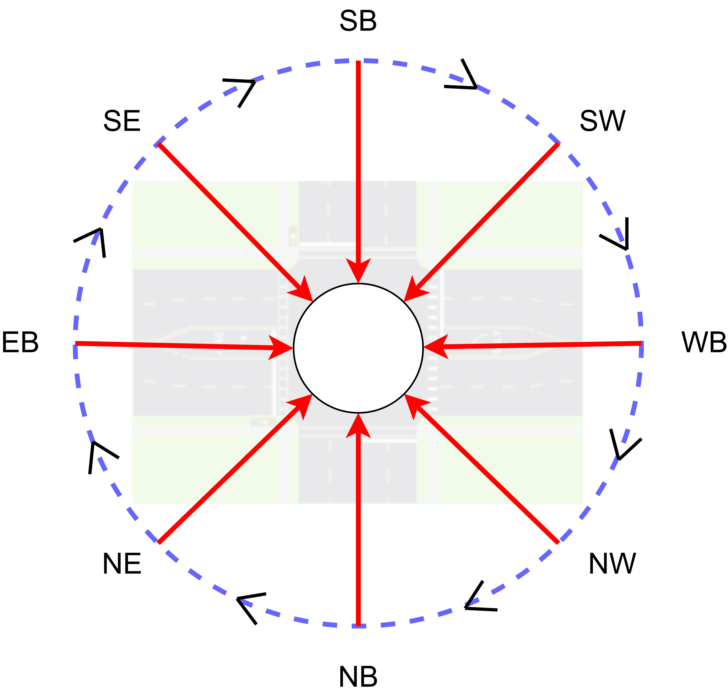

Figure 1: Direction order in Synchro

Phase mapping. After identifying the direction mapping, the next step is to perform signal phase mapping. The signal phase mapping step aims to organize signal phase order and generate lane-based signal states. As previously stated, signal phase settings vary in SUMO and Synchro. Synchro uses a Ring-and-Barrier Designer for simulating signal ring-barrier controllers. Once a phase number is assigned to the BRP (barrier, ring, and position) field, Synchro automati-cally conducts signal phase transitions. SUMO, on the other hand, utilizes a state-based string where each character represents the signal color (green (G, g), yellow (y), red (r)) for each connection, with uppercase indicating protected movements and lowercase for permit-ted ones. Different models and algorithms have been developed in SUMO to support pretimed, actuated and National Electrical Manufacturers Association (NEMA) type signal controller for managing Dual-Ring-Barrier control signals [19], [20]. Real-world signal scenar-ios, however, can be more complex, involving multiple rings or specialized pedestrian crossings.

demonstrates our method using a Ring-Barrier-Controlled signal with three rings as an example. The process begins with extracting all valid phases from Synchro. We then apply a Breadth-First Search algorithm [21] to identify all feasible combinations of green light phases. Following this, the Connection-To-Direction mapping is utilized to translate the Synchro Phase number into SUMO lane-based states. This translation is facilitated by correlating SUMO’s ‘linkIndex’ with the corresponding lane group in Synchro. The final step in-volves conducting a bitwise comparison between each pair of adjacent green phases. This is complemented by the interpolation of yellow and all-red phases to ensure a seamless transition and accurate signal timing.



*Signal Phase Mapping Example*

You will need to electronically submit the paper in Portable Document Format (.pdf) through [the](http://www.wintersim.org/) [conference website](http://www.wintersim.org/). The .pdf file format allows for automatic page counting and ensures that the page limit has been followed. If the paper is accepted, you will also need to electronically submit the word-processor source file (.docx) for the final version of your paper. The editors may return the file to you with the request to make changes to conform to conference guidelines. For minor changes, the editors may make the changes themselves. The final .pdf files are generated by the conference proceedings editors.

You will also need to transfer the copyright of your article to the WSC using the copyright transfer form that will be available via the conference website at the appropriate time. *For your paper to be published by the WSC, you must complete the transfer of copyright.* When you have successfully transferred the copyright, you will receive a .pdf receipt.

If you are unable to satisfy these requirements, you should contact the proceedings editors.

## Traffic Flow Conversion

Turning volume from UTDF file indicates the volumes in vehicles per hour. In Synchro, turning volumes are specified in each direction (Left, Through, Right), there is no U-turn volumes specified in the original (most cases) setting, as SUMO will automatically generate U-turn volumes which will finally influence the accuracy of the conversion, to solve this problem, we prohibited U-turn in converted SUMO network (see 2.5.3). In this section, we extract left, through and right turn volumes and generate flow files for SUMO.

## Sigma-X Powered Performance Calculation

Sigma-X is a power engine developed using VBA by Prof. Milan from University of Wyameone. The original development from 2012-2022 (GNU Licensed). We continue the development from 2025 to fix errors in handling large and complex network and controlling the results generation.

By extracting intersection volumes, signals, inbounds and outbounds, link and lanes, the Sigma-X calculate and visualize key features for signalized intersections, there are V / C ratio, Level of Service, turning volumes, signal phasing, control delay (seconds), split durations (seconds), movement capacities (vehicle per hour) and more.

### Overview of Signalized Intersection

The overview of the signalized intersection will combine extracted and calculated parameters into one figure with centralized with the intersection name. Figure 1 shows the sample overview features. As shown in the figure, the center will show the intersection name, then from center extended with movement directions for each direction. There are number of lanes and volumes are corresponding to each movement and will be updated from UTDF data. The right turn on read (RTOR) specified for each right turn lane as well. Then speed will be updated as well, such EB Speed, WB Speed, NB Speed and SB Speed. For each direction, the street name will also be updated.

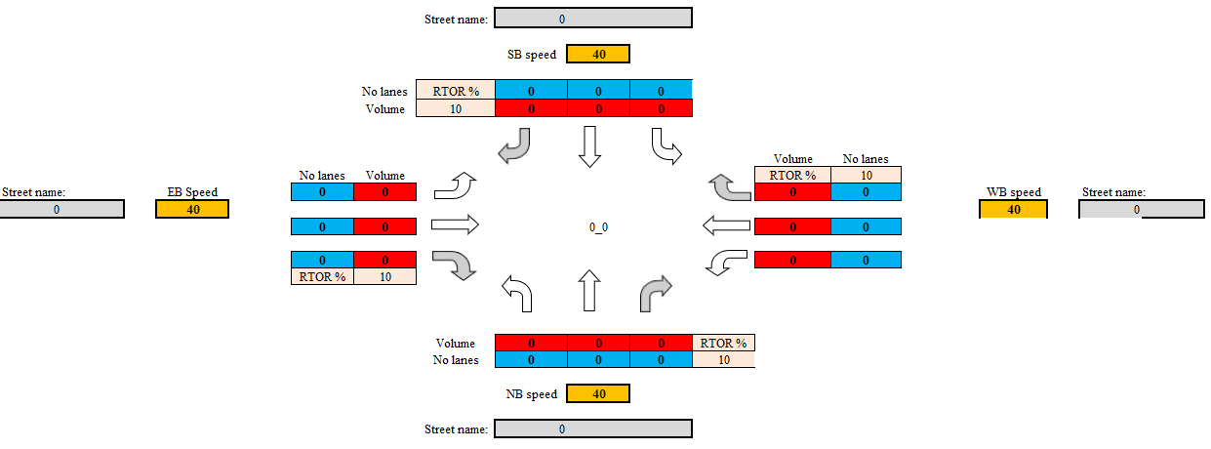

Figure 1 Overview of the signalized intersection

### Signal Phasing

signal phasing information is extracted and processed from Synchro UTDF files, which provide detailed signal timing parameters such as cycle length, phase splits, offsets, and protected/permissive movements. These raw data are parsed to reconstruct the operational logic of traffic signals at each intersection, offering insight into how signal phases are coordinated across the network.

After extraction, the processed signal phasing data are used to generate visual representations in the form of phase timing charts. These charts display the sequence and duration of each phase within a cycle, highlighting overlaps and coordination opportunities between adjacent intersections. This visualization not only aids in the verification of signal timing consistency but also supports further analyses such as delay estimation, progression evaluation, and scenario simulation under varying traffic conditions.

### Turning Volume and Number Lanes

Turning volume data provide essential insight into intersection-level traffic dynamics by capturing the directional flow of vehicles—such as left turns, through movements, and right turns—at each approach. In this study, turning volume information is extracted directly from Synchro UTDF (Universal Traffic Data Format) files, which include detailed counts for each movement during peak periods. These data allow for a precise understanding of demand distribution and intersection load across the network.

To facilitate interpretation, the extracted turning volumes are visualized using movement-specific charts that depict traffic flow intensity by direction. These charts help identify imbalances in movement demand, potential bottlenecks, and critical turning movements that may require signal timing adjustments or geometric improvements. By presenting the turning volumes in a clear and intuitive format, the analysis supports more informed decision-making in traffic signal optimization and intersection design.

### V/C Ratio and Movement Capacity (VPH)

The Volume-to-Capacity (V/C) ratio is a key performance indicator used to evaluate the operational efficiency and level of service at signalized intersections. In this study, V/C ratios are derived from Synchro UTDF (Universal Traffic Data Format) data, which include traffic volumes and lane capacities for each movement. By calculating the V/C ratio for individual movements and approaches, the analysis quantifies the degree of congestion and identifies locations where demand approaches or exceeds available capacity.

The Volume-to-Capacity (V/C) ratio is a key performance metric for evaluating intersection performance.

In this study, the V/C ratio is calculated using data extracted from Synchro UTDF files, which provide detailed traffic volumes and lane capacities for each movement. This ratio quantifies the degree of saturation at an intersection, with higher values indicating potential congestion. Visual charts generated from the V/C data highlight critical movements where demand approaches or exceeds capacity, serving as an essential diagnostic tool for identifying intersections that may require signal optimization or capacity enhancements.

In addition to the V/C ratio, movement capacity is assessed to gain deeper insight into the operational limits of each intersection movement. Movement capacity represents the maximum number of vehicles that can be processed by a specific approach under prevailing signal timing and geometric conditions. By analyzing both V/C ratios and movement capacities together, the study provides a comprehensive view of intersection performance, allowing for a more precise identification of areas where traffic flow improvements are needed. The visualizations further aid in comparing the actual demand against the theoretical capacity, thereby supporting targeted interventions to enhance overall network efficiency.

To enhance interpretability, the computed V/C ratios are presented through visual charts that illustrate the performance of each intersection. These charts highlight critical movements with high V/C ratios, indicating potential delays or capacity shortfalls. Such visualization supports quick identification of problem areas within the network and serves as a basis for prioritizing signal optimization, capacity enhancements, or geometric redesigns.

### Level of Service and Control Delay

Level of Service (LOS) is a standardized metric used to evaluate traffic performance at signalized intersections, reflecting the quality of traffic flow experienced by drivers. LOS is categorized into six levels, from A to F, where LOS A represents minimal delays and high operating efficiency, and LOS F indicates excessive delays and breakdown conditions. In this study, LOS is determined in accordance with the methodologies defined in the Highway Capacity Manual (HCM 6th Edition), which classifies LOS based on control delay per vehicle measured in seconds. Control delay measures the additional travel time a vehicle experiences at an intersection compared to uninterrupted flow. By applying methodologies outlined in the Highway Capacity Manual (HCM), control delay thresholds are used to assign each approach an appropriate LOS category, providing a quantitative measure of operational efficiency.

Using data extracted from Synchro UTDF files—such as approach volumes, lane configurations, and signal timing—control delays are calculated, and corresponding LOS values are assigned for each approach and intersection. The LOS results are then visualized through intuitive charts that highlight operational efficiency across the network. The calculated LOS values, along with their corresponding control delays, are visualized through detailed charts. These charts not only depict the overall level of service at various intersections but also highlight the specific delays contributing to suboptimal performance. Such visualizations enable traffic engineers to quickly identify intersections experiencing high control delays (e.g., LOS E or F), thereby informing targeted interventions such as signal retiming, lane reconfigurations, or other capacity enhancements to improve network performance.

### Split Durations (Seconds)

Split duration refers to the allocation of green time among different signal phases within a cycle at a signalized intersection. It is a critical parameter in signal timing that directly influences intersection performance, delay, and traffic progression. In this study, split durations are extracted and calculated from Synchro UTDF (Universal Traffic Data Format) files, which contain detailed signal timing plans including green, yellow, and red intervals for each phase.

The extracted split durations are used to generate visual charts that illustrate how green time is distributed across different movements within each cycle. These charts help to assess the balance between traffic demand and signal timing, highlighting potential inefficiencies such as over- or under-allocated phases. Such visualization supports informed adjustments to signal timing plans, promoting more effective utilization of intersection capacity and smoother traffic flow.

## SUMO Generation

SUMO network will be generated by using netconvert, jrrouter tools. There are several steps to automatically convert Synchro network to SUMO network. AS we have geocoded intersections, we will then be geocoding links and lanes from the intersections. After network have been created, the next step is to integrating signal to the generated network. Then the flow data could be converted by configuring the turning for the sumo network. The last step is to generate the SUMO configuration file for simulation in sumo.

### Network Conversion

As we have the real-world coordinates of intersections, we crate nod.xml file in SUMO format. The next step is to generate the links and lanes from the intersections. We will creatre edg.xml file in SUMO format. Then by combing nod.xml and edg.xml, using netconvert tool to create net.xml. We can create links and lanes with default width (From UTDF data).

### Signal Integration

After the generated the network, the signal integration is implemented. The updated signal information is in net.xml.

### Turning Configuration

The first step is to generate flow.xml file from turning volumes in the UTDF. According to the flow.xml and net.xml, using jtrrouter tool to generate rou.xml file. To correctly integrate turning flow from Synchro to SUMO, there are some constraints need to update. In the creation of rou.xml, we need to forbit loops to avoid vehicles going out at the dead-end route and come back at the dead-end route then. After the rou.xml files generated, we need to invalid U-turn in the network. The reason to invalid U-turn is because the Synchro network does not include U-turn information in the most cases and the SUMO network generation will always generate U-turn from given nod.xml and edg.xml. The additional U-turn volumes will be casing the simulation in SUMO getting wrong.

### SUMO Configuration

After SUMO network file generated, we extract the staring time and duration from UTDF and crate SUMO configuration file for microsimulation.

# CASE STUDY

## Study Area

This study selects downtown Tempe as the study area, as depicted in Figure 1,

There are 755 intersections in the network with 275 signalized intersections.

Figure 1: City of Tempe showing in OpenStreetMap, Synchro network and SUMO network (order from left to right)

illustrates the complexity of intersections within a large-scale network, highlighting the challenges associated with integrating Synchro and SUMO. The network features a range of intersection types, extending beyond the conventional four-way to include three-way and even five-way and six-way intersections. Additionally, the presence of signal protec-tion at these intersections varies greatly, encompassing factors such as pedestrian phases, protected left or right turns, and different signal timing plans ranging from fixed to adaptive and actuated timing. This diversity significantly complicates the process of implementing in-tegration between Synchro and SUMO, as each intersection type and signalization approach demands careful consideration and unique handling within the simulation models.

## Automation in Intersection Key Features Visualization

## Automation in SUMO Microsimulation

### Network

### Intersection Features

### Signal and Turning Flow

# CONCLUSION AND FUTURE WORK

In this paper, we explored the process of integrating traffic signal data from Synchro to SU-MO, identifying both the feasibility and challenges involved. Our approach began with a comparative analysis of traffic network features, data formats, and signal timing schemas between the two platforms. Despite similarities in road network features, significant differences in traffic signal timing plan encodings presented obstacles, especially in large-scale networks.

To overcome these challenges, we introduced a four-stage approach encompassing Data Preparation, Connection-to-Direction Mapping, Signal Phase Mapping, and Data Revision and Output. This methodology focused on extracting relevant signal timing and road features, aligning inbound directions, and generating lane-specific signal states for each timing phase. We then converted this data into SUMO's XML format. Our semi-automated pipeline, developed in Python, was tested on two Synchro models in downtown Seattle. The success rate exceeded 85%, demonstrating the pipeline's ability to handle various intersection layouts and signal controller types. However, the integration is not flawless in large-scale networks, necessitating manual checks for complex intersections.

The proposed four-stage approach can help researchers and modelers integrate the signal timing data from Synchro to SUMO more efficiently. This study delved into the intricacies of signal control mechanisms within both platforms. For future work, this framework could be foundational for extending traffic signal integration from Synchro/SUMO to other platforms. While the results in large-scale networks are promising, they still require manual validations and revisions in complex scenarios, such as the mismatching geometry coding between Synchro and SUMO and intersections with an exclusive pedestrian phase. Further refinement through specific algorithms is needed to enhance signal integration accuracy. Additionally, we envision supporting the integration of advanced signal control features, such as coordinated signal control, to elevate the quality of simulation. Beyond traffic signal control integration, this four-stage approach may hold the potential for integrating a wider range of Synchro features into SUMO, including links, routes, and detectors.

ACKNOWLEDGMENTS

Place the acknowledgments section, if needed, after the main text but before any appendices and references. The section heading is not numbered. These instructions are adapted from instructions that have been iteratively updated and improved by proceedings editors and several other individuals, who are too numerous to name separately, since the first set of instructions was written by Barry Nelson for the 1991 WSC.

REFERENCES

Banks, J., J. S. Carson, B. L. Nelson, and D. M. Nicol. 2000. *Discrete-Event System Simulation*. 3rd ed. Upper Saddle River, New Jersey: Prentice-Hall, Inc.

Cheng, R. C. H. 1994. “Selecting Input Models”. In *1994 Winter Simulation Conference (WSC)*, 184–191 <https://doi.org/10.1109/WSC.1994.717117>.

Chien, C. 1989. “Small Sample Theory for Steady State Confidence Intervals”. Technical Report No. 37, Department of Operations Research, Stanford University, Stanford, California.

Gupta, S. S., K. Nagel, and S. Panchapakesan. 1973. “On the Order Statistics from Equally Correlated Normal Random Variables”. *Biometrika* 60(2):403–413.

Hammersley, J. M. and D. C. Handscomb. 1964. *Monte Carlo Methods*. London: Methuen.

Hunter, S. R. and R. Pasupathy. 2022. “Central Limit Theorems for Constructing Confidence Regions in Strictly Convex Multi-Objective Simulation Optimization”. In *2022 Winter Simulation Conference (WSC)*, 3015-3026 <https://doi.org/10.1109/WSC57314.2022.10015390>.

Law, A. M. and W. D. Kelton. 2000. *Simulation Modeling & Analysis.* 3rd ed. New York: McGraw-Hill, Inc.

Paszek, P., S. Ryan, L. Ashall, K. Sillitoe, C. V. Harper, D. G. Spiller *et al.* 2020. “Population Robustness Arising from Cellular Heterogeneity”. *Proceedings of the National Academy of Sciences* 107(25): 11644-11649.

Powell, J. H. and N. Mustafee. 2017. “Widening Requirements Capture with Soft Methods: An Investigation of Hybrid M&S Studies in Healthcare”. *Journal of the Operational Research Society* 68(10):1211-1222.

Rabe, M., F. Dross, and A. Wuttke. 2017. “Combining a Discrete-event Simulation Model of a Logistics Network with Deep Reinforcement Learning”. In *Proceedings of the MIC and MAEB 2017 Conferences*, July 4th-7th, Barcelona, Spain, 765-774.

Schruben, L. W. 1979. “Designing Correlation Induction Strategies for Simulation Experiments”. In *Current Issues in Computer Simulation*, edited by N. R. Adam and A. Dogramaci, 235–256. New York: Academic Press.

Sharon Parq Associates. 2018. WordTips: Numbering Equations. <http://word.tips.net/Pages/T000273_Numbering_Equations.html>, accessed 15th April.

Steiger, N. M. 1999. *Improved Batching for Confidence Interval Construction in Steady-State Simulation*. Ph.D. thesis, Department of Industrial Engineering, North Carolina State University, Raleigh, North Carolina. <http://www.lib.ncsu.edu/resolver/1840.16/4713>, accessed 12th February 2019.

The University of Chicago Press 2010. *The Chicago Manual of Style*. 16th ed. Chicago: The University of Chicago Press. <http://www.chicagomanualofstyle.org>.

WSC 2025. “Winter Simulation Conference”. Accessed 20th January 2025.

AUTHOR BIOGRAPHIES

Author biographies are mandatory for all authors and given in the same sequence as in the running head. Use a smaller font (9 pt) with a 10.5pt line spacing (MS Word style AuthorBio). Giving an email address is mandatory and the author’s name is set in bold capitals (see the examples below). Separate the authors by an empty line with the same style. Give only one paragraph per author but sufficient information to understand the author’s position and scientific background.

**ELIE AZAR** is a Canada Research Chair and Associate Professor in the Department of Civil and Environmental Engineering at Carleton University in Ottawa, Canada. His research interests include human-centered building design and operation, occupant behavior modeling, building performance simulation, agent-based modeling, and data-driven predictive models. He has authored numerous scientific research articles in his field and edited books focused on sustainability, smart cities, and artificial intelligence. His email address is [elie.azar@carleton.ca](mailto:elie.azar@carleton.ca) and his website is <https://carleton.ca/cee/profile/elie-azar/>.

**ANATOLI DJANATLIEV** is an Associate Professor for Computer Science at the University of Applied Sciences Ingolstadt. He received his Ph.D. degree (Dr.-Ing.) and his M.Sc. in computer science (Dipl.-Inf. Univ.) from the engineering faculty of the University of Erlangen-Nuremberg in 2015 and 2008, respectively. Until 2010, he worked as a software engineer within the area of model-based testing and automated test case generation. Thereafter, he was leading a research grop for Connected Mobility at the University of Erlangen-Nuremberg. His previous research focus was related to prospective assessments of health technologies, and healthcare decision-support. His current research interests include various topics on simulation and modeling using agent-based simulation, and hybrid simulation. Major application areas are simulation of healthcare systems, vehicular networks, innovative aspects of connected mobility, and future mobility services. His email address is [anatoli.djanatliev@thi.de](mailto:anatoli.djanatliev@thi.de) and his website is <https://www.thi.de/en/computer-science/people-i/prof-dr-anatoli-djanatliev>.

**ALISON HARPER** is a Lecturer in Operations and Analtyics at University of Exeter Business School. Her research interests include open science for computer simulation, real-time discrete-event simulation, and hybrid modeling. Her email address is [a.l.harper@exeter.ac.uk](mailto:a.l.harper@exeter.ac.uk) and her website is <https://experts.exeter.ac.uk/34992-alison-harper>.

**CHRISTOPH KOGLER** is a postdoctoral project leader at the University of Natural Resources and Life Science Vienna, Austria. His research focuses on sustainability, supply chain management, transportation and logistics. As a passionate lecturer, he is committed to simulation education, has won two teaching awards, and has been nominated twice for Austria’s State Award of Teaching. He conducted research stays at the University of California in Berkeley, Brno University of Technology, and University of Freiburg. He serves as section editor for wood value chain management, economics, and logistics as well as editorial board member for DREWNO and reviewed for more than 30 journals. His email address is [christoph.kogler@boku.ac.at](mailto:christoph.kogler@boku.ac.at) and his website is <https://forschung.boku.ac.at/fis/staff?name=ChristophKogler>.

**VARUN RAMAMOHAN** is an Associate Professor in the Department of Mechanical Engineering at the Indian Institute of Technology Delhi, located in New Delhi, India. His research interests include probabilistic modeling, simulation and simulation optimization, with applications in healthcare operations, health economics and outcomes research, and military operations. His email address is [varunr@mech.iitd.ac.in](mailto:varunr@mech.iitd.ac.in) and his website is https://web.iitd.ac.in/~varunr.